MLA0302 – Reinforcement Learning
CO2-AT1

Code of Conduct:
I _____M Poojitha Reddy- 192472352__ (Name / Reg No) certify that this submission is my original work
and that I have adhered to the guidelines specified for this assessment.
I understand that any violation of academic integrity rules will result in disciplinary action.
Signature of the student:
M Poojitha Reddy

Industry Problem Task Duration
- Explain how Reinforcement Learning can be applied to optimize delivery routes in a logistics system. Identify the possible states, actions, rewards, and policy. Discuss how continuous learning improves efficiency over time. (5 Marks)

Reinforcement Learning (RL) helps delivery vehicles learn the most efficient routes by interacting with the environment and improving decisions through rewards.
MDP Components
- States: Current vehicle location, traffic conditions, fuel level, weather, number of pending deliveries.
- Actions: Choose the next road, reroute, stop, or continue on the current path.
- Rewards: Positive reward for on-time deliveries, shorter travel time, and lower fuel consumption. Negative reward for delays, traffic congestion, and unnecessary distance.
- Policy: Learns the best routing strategy that maximizes long-term rewards.
Continuous Learning
The RL agent continuously learns from GPS data, traffic updates, and delivery outcomes. As more experience is gained, it identifies better routes, reduces delivery costs, improves fuel efficiency, and increases customer satisfaction.
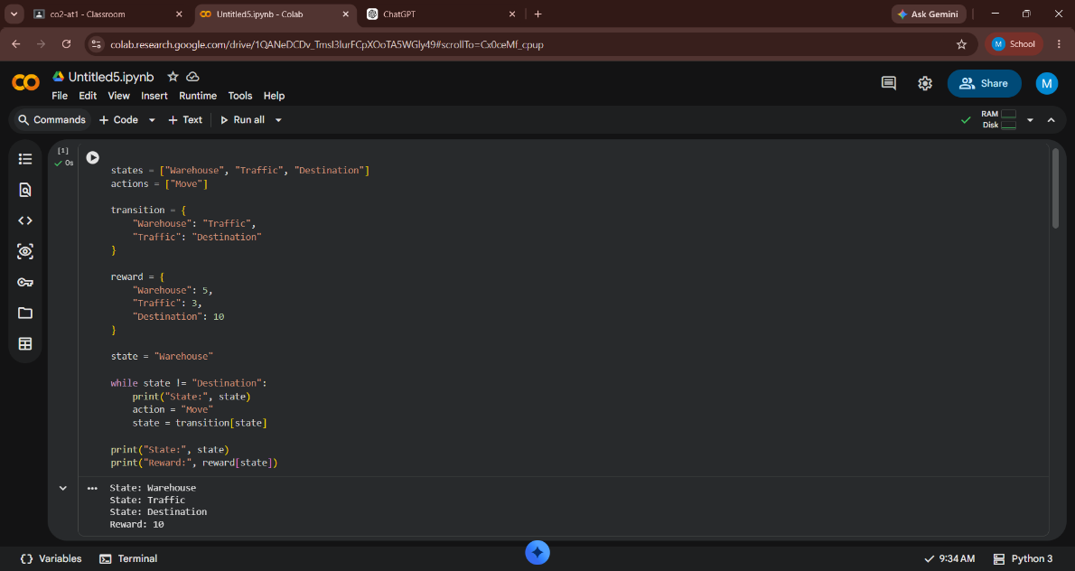

- Apply Reinforcement Learning concepts to a fraud detection system in fintech. Define the state space, action space, and reward mechanism. Explain how exploration strategies improve detection accuracy

RL enables financial systems to learn patterns of fraudulent transactions and improve detection through experience.
RL Components
- State Space: Transaction amount, location, user history, device information, transaction frequency.
- Action Space: Approve transaction, reject transaction, request verification.
- Reward Function: Positive reward for correctly identifying fraud; negative reward for false alarms or missed fraud.
Exploration Strategy
Exploration allows the agent to test different detection strategies, helping discover new fraud patterns. As learning progresses, the system balances exploration and exploitation to improve fraud detection accuracy while minimizing false positives.

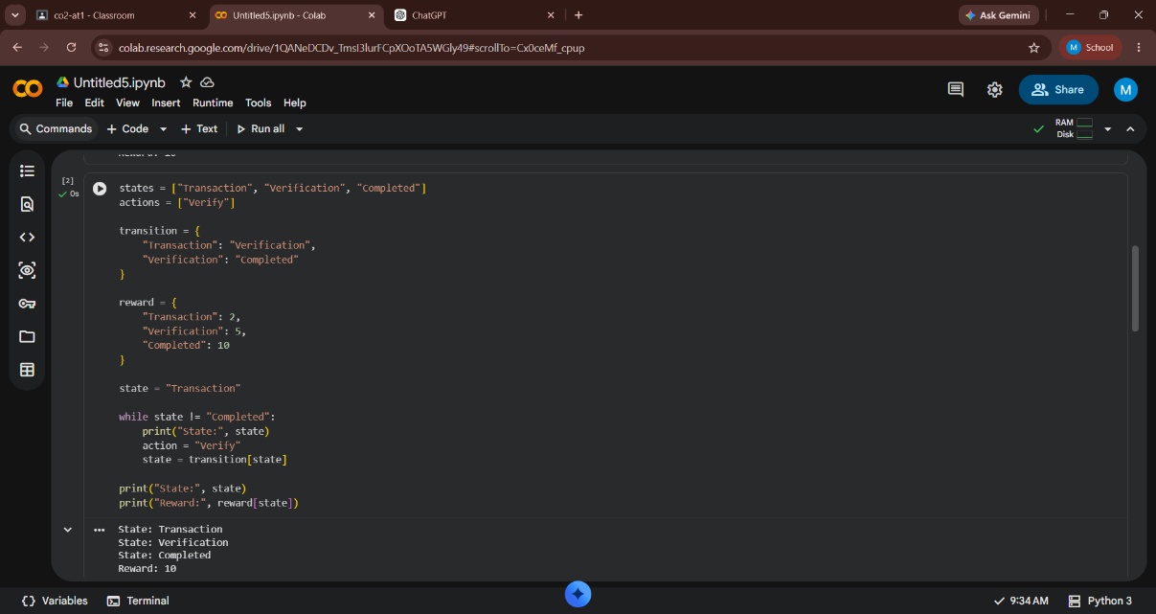

- Illustrate how Reinforcement Learning is used in a streaming platform for content recommendation. Discuss the impact of delayed rewards, user feedback, and changing preferences on learning performance.

Streaming platforms use RL to recommend movies, songs, or videos that maximize user engagement and satisfaction.

Learning Process
- The agent recommends content based on viewing history and user preferences.
- Delayed Rewards: Rewards are received after users watch, like, rate, or complete the recommended content rather than immediately.
- User Feedback: Watch time, likes, dislikes, ratings, and skipped content act as reward signals.
- Changing Preferences: User interests change over time, so the RL agent continuously updates its recommendation policy.

This helps improve personalization, increase watch time, and enhance user retention.

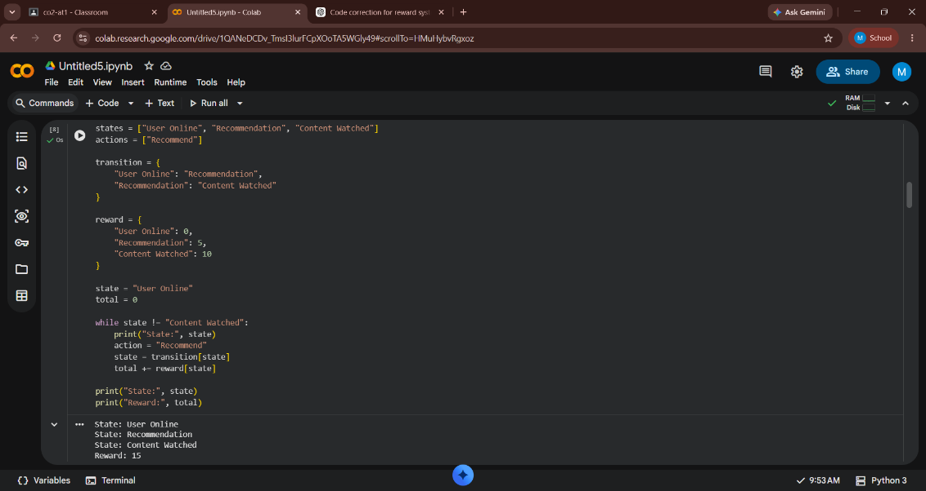

- Evaluate the effectiveness of Reinforcement Learning in predictive maintenance compared to traditional rule-based approaches. Discuss risks and reliability concerns in industrial environments.

RL predicts the optimal time for equipment maintenance by learning from machine performance data.

Advantages over Rule-Based Systems
- Learns maintenance schedules automatically instead of following fixed rules.
- Reduces unexpected equipment failures.
- Minimizes maintenance costs and machine downtime.
- Continuously adapts to equipment wear and operating conditions.

Risks and Reliability
RL requires large amounts of training data and safe exploration. Incorrect decisions during learning may cause equipment damage, so simulation and continuous monitoring are necessary before deployment in industrial environments.
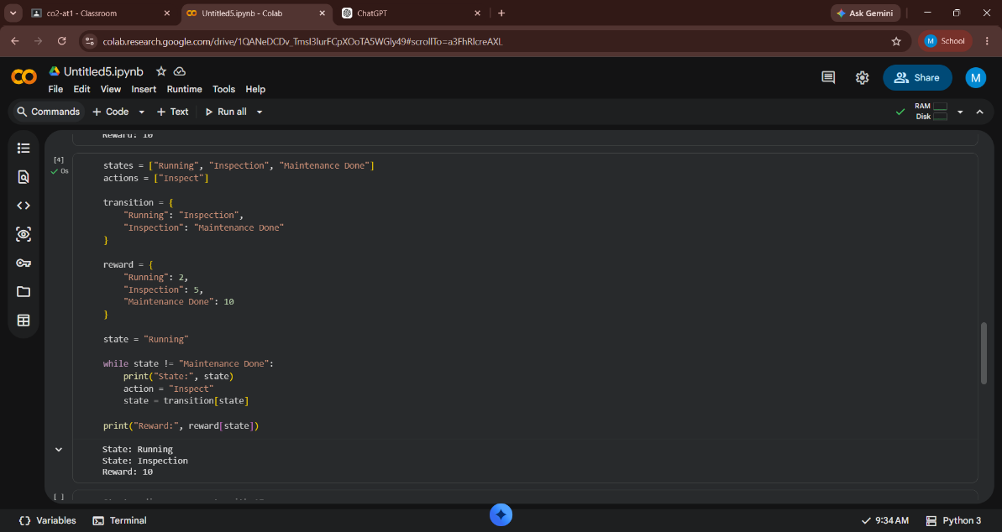
)

- Analyze how Reinforcement Learning can be used to optimize transportation systems such as bus scheduling or route allocation. Define states, actions, and rewards, and discuss how real-time data improves performance. (5 Marks)

RL optimizes transportation systems by improving bus scheduling, route allocation, and traffic management.
MDP Components
- States: Bus location, passenger demand, traffic conditions, and schedule status.
- Actions: Change routes, adjust departure times, allocate additional buses, or maintain the current schedule.
- Rewards: Positive reward for reducing passenger waiting time, improving punctuality, and minimizing fuel usage. Negative reward for delays and congestion.
Real-Time Data
Using GPS, traffic sensors, and passenger demand data, the RL agent continuously updates schedules and routes, improving service efficiency and reducing operational costs.

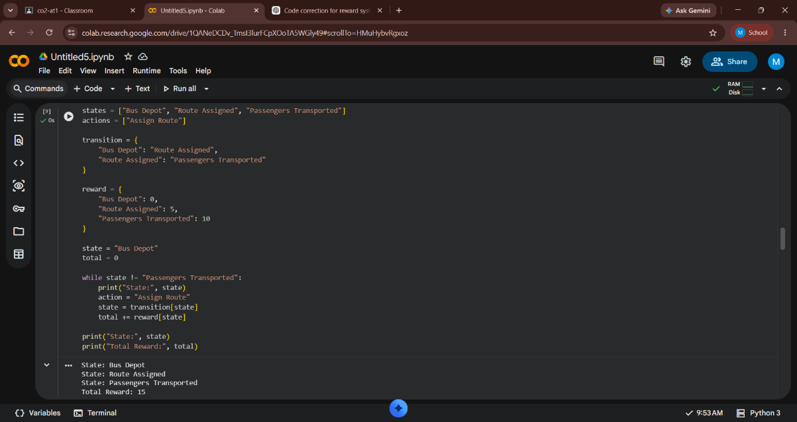

- Apply Reinforcement Learning to dynamic pricing in e-commerce. Define the state space, action space, and reward function. Discuss challenges in balancing exploration and exploitation. (5 Marks)

RL adjusts product prices dynamically to maximize revenue while maintaining customer demand.
RL Components
- State Space: Product demand, inventory level, competitor prices, season, customer behavior, and market trends.
- Action Space: Increase price, decrease price, or keep the price unchanged.
- Reward Function: Revenue earned, profit margin, sales volume, and customer satisfaction.

Exploration vs Exploitation
The RL agent explores new pricing strategies while exploiting successful ones. Maintaining the right balance helps maximize long-term profits without discouraging customers or losing market competitiveness.

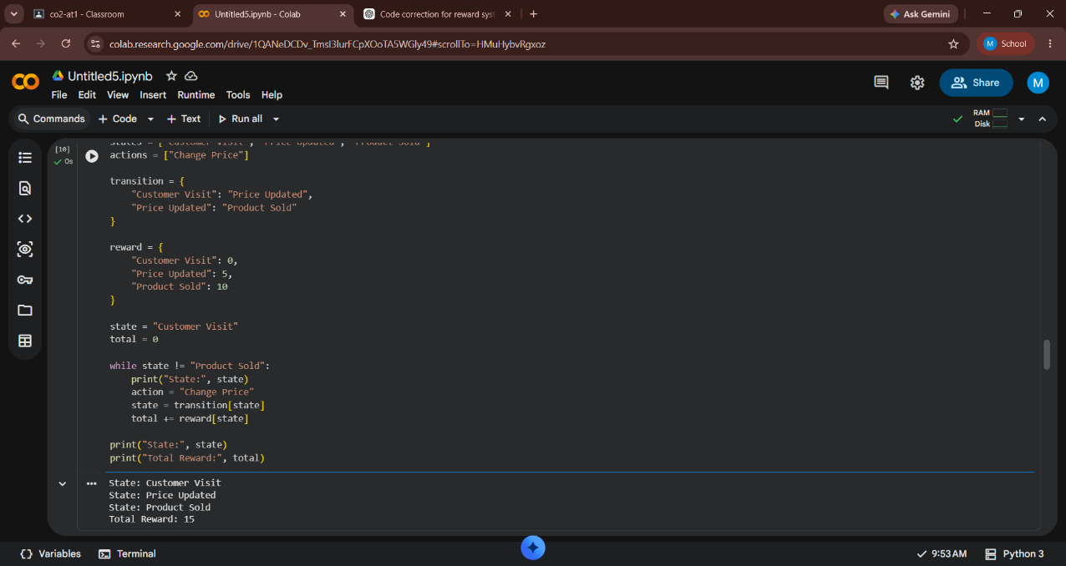

- Illustrate the use of Reinforcement Learning in smart city waste management systems. Identify the MDP components and discuss how continuous updates improve operational efficiency. (5 Marks)

RL improves waste collection by determining the best routes and collection schedules using real-time information.

MDP Components
- States: Waste bin fill level, truck location, traffic conditions, and fuel level.
- Actions: Dispatch trucks, choose collection routes, or postpone collection.
- Rewards: Positive reward for timely waste collection, lower fuel consumption, and reduced operational cost. Negative reward for overflowing bins and unnecessary trips.
- Policy: Learns the most efficient collection strategy.

Continuous Updates
IoT sensors provide real-time information about bin levels. The RL agent updates its policy continuously, improving route efficiency, reducing fuel consumption, and maintaining cleaner cities.

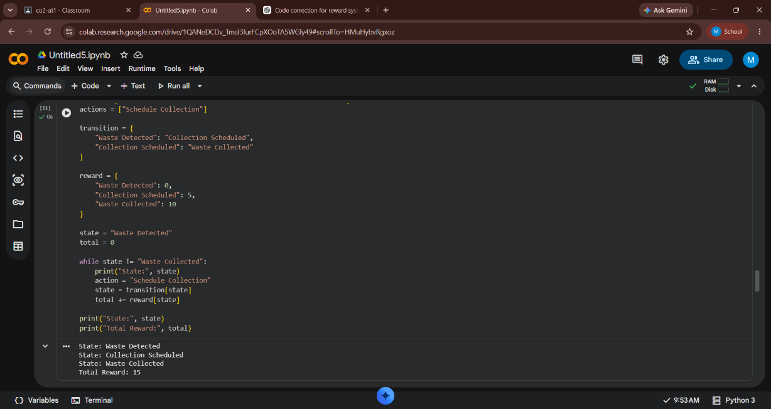

- Evaluate how Reinforcement Learning can be used in network bandwidth allocation in telecommunications. Define states, actions, and rewards, and examine how the system adapts to dynamic conditions. (5 Marks)

RL helps telecommunications networks allocate bandwidth efficiently under changing network conditions.

RL Components
- States: Current bandwidth usage, network congestion, active users, packet loss, and latency.
- Actions: Increase, decrease, or redistribute bandwidth among users or services.
- Rewards: Positive reward for higher throughput, lower latency, and better Quality of Service (QoS). Negative reward for congestion and packet loss.

Dynamic Adaptation
The RL agent continuously learns from network traffic patterns and adjusts bandwidth allocation in real time, improving network performance and user experience.

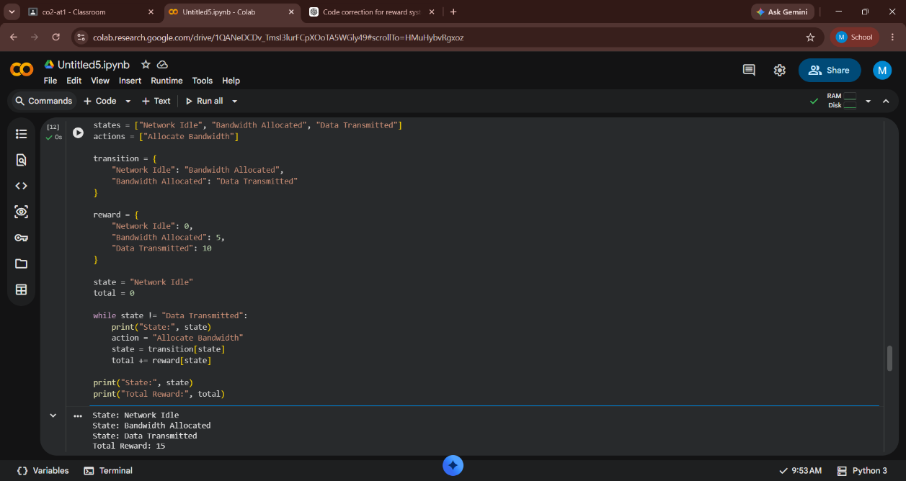

- Analyze the application of Reinforcement Learning in portfolio management in finance. Discuss advantages over traditional models and challenges such as risk and delayed rewards. (5 Marks)

RL assists investors in making investment decisions that maximize long-term returns while managing financial risk.

Advantages
- Learns from continuously changing market conditions.
- Optimizes long-term investment returns.
- Adapts automatically to market fluctuations.
- Handles complex investment strategies better than fixed-rule methods.

Challenges
Investment returns are often delayed, making learning difficult. Market volatility, uncertainty, and financial risk require careful reward design and extensive historical and real-time market data for effective decision-making.

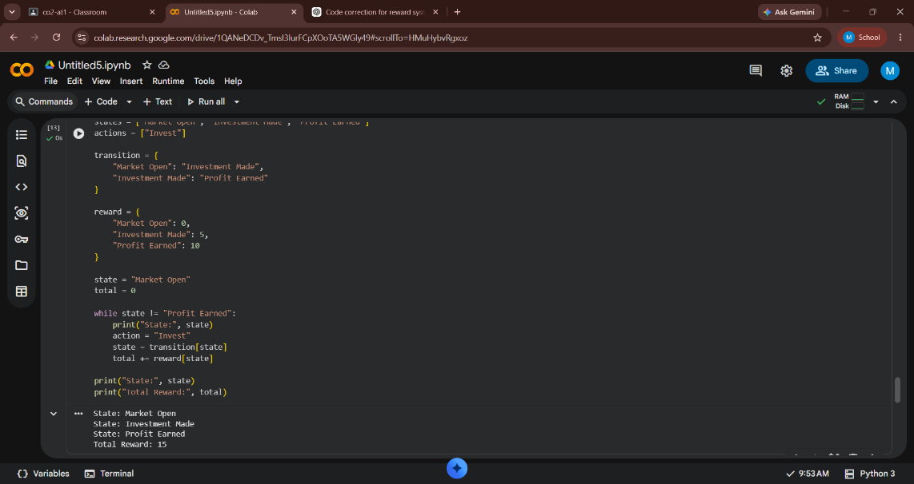

- Justify the use of Reinforcement Learning in renewable energy management systems. Define the RL framework components and discuss the impact of environmental uncertainty on decision-making.

RL optimizes the generation, storage, and distribution of renewable energy sources such as solar and wind power.

RL Framework
- States: Energy demand, battery charge level, weather conditions, electricity generation, and grid status.
- Actions: Store energy, distribute power, charge/discharge batteries, or purchase additional electricity.
- Rewards: Positive reward for efficient energy usage, reduced operating cost, and stable power supply. Negative reward for energy wastage, battery overuse, and power shortages.
- Policy: Learns the best energy management strategy.

Environmental Uncertainty
Renewable energy depends on unpredictable weather conditions. RL continuously learns from changing environmental data, allowing better energy forecasting, efficient resource utilization, and improved grid reliability.

